Important
Read the License Agreement and, if and only if you agree with its terms, proceed with the installation steps below.

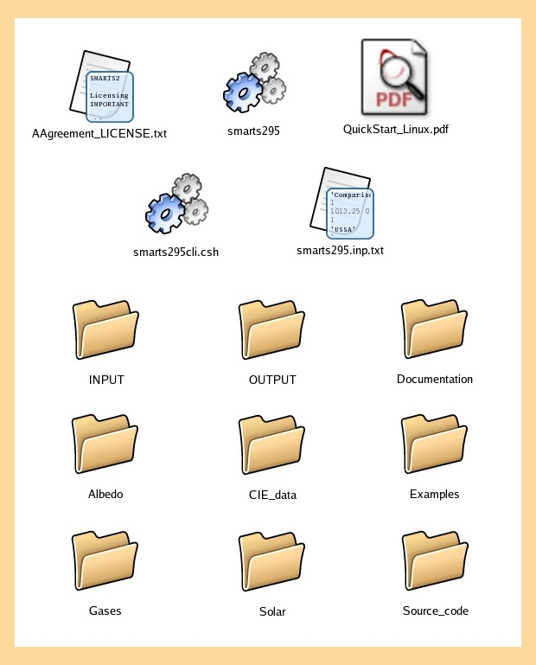
Folder content
A typical screenshot of the SMARTS_295_Linux folder is shown here. The exact appearance depends on the window manager you use and its settings.

The ‘smarts295.inp.txt’ file is a sample input file that you can use to familiarize yourself.

The User’s Manual can be found in the Documentation folder.

Command line execution

To run SMARTS, open a Terminal window or an xterm and move to the directory where you have extracted the package:

cd /install_path/SMARTS_295_Linux

and hit Enter. Then type

./smarts295

and hit Enter. This first message appears:

***********************************
Welcome to SMARTS, version 2.9.5!
***********************************
$$$ SMARTS_295> Use batch mode?
[If YES (or Y), this window will close and execution
will be using the default input file smarts295.inp.txt]
(Y/N) ==>

If you type “y” or “yes” and hit Enter, execution begins immediately. The following message appears when execution ends:

Total CPU time: 0.142 sec

It is clear that the actual execution time will vary according to your computational power. Execution of the sample input file must have created three separate output files: ‘smarts295.out.txt’, ‘smarts295.ext.txt’ and ‘smarts295.scn.txt’, all located at the root of the SMARTS_295_Linux folder.

If you rather type “n” or “no” and hit Enter, the following message appears:

$$$ SMARTS_295> What is the path to the input file?
* Type only "." if in the same folder
* Do NOT type the last "/" of the chain
* 2000 characters max. ==>

Type the path pointing to your input file or type “.” if the file resides in the current folder. For instance, type ‘INPUT’ if it is located in the INPUT folder of SMARTS_295_Linux. Hit Enter and the program will then ask for the proper filename:

$$$ SMARTS_295> Generic name for all input/output files
* without any extension
* 100 characters max.)? ==>

For instance, type “Test_for_July” if the input file is ‘Test_for_July.inp.txt’. Hitting enter results in:

$$$ SMARTS_295> You chose the following filenames:
Input: Test_for_July.inp.txt
Output: Test_for_July.out.txt
Spreadsheet-ready: Test_for_July.ext.txt
Smoothed results: Test_for_July.scn.txt
$$$ SMARTS_295> Is this OK? (Y/N) ==>

Type “y” if it is OK, or “n” if not, and hit Enter. If you chose yes, execution starts normally. If you chose no, the previous message reappears and the cycle continues until you reply yes. The output files will be located in the same folder as the input file, e.g., in the INPUT folder for this example.

To use any sample input file contained in the Example subfolders within the Examples folder, move it to the root of the SMARTS_295_Linux folder, thus replacing any pre-existing file of the same name. However, before undertaking the execution of any new run using an input file with the same name, it is imperative to either rename the existing output files, or to move them to the OUTPUT folder or any other folder. Failing to do so would prevent proper execution.
However, you can always change the appropriate options in the “OPEN” statement of the output files, so that at anytime they are overwritten. Recompile the program and run again. The source code resides in the “Source_Code” folder and any Fortran77 compiler would do the job. For example the command “g77 –o smarts295 smarts295.f” should complete without any errors and create an executable called “smarts295”.

Batch mode
A sample shell file, called smarts295cli.csh, is provided which further enhances the batch capabilities of the smarts295 code. The script assumes a variety of different inputs, e.g. smarts_01.inp.txt, smarts_june.inp.txt, smarts_20050910.inp.txt. The executable is assumed to reside in the root directory of the code and is better to recompile the program with “batch=.TRUE.” (line 188 of the code).

What’s next?
At this point, you are certainly eager to customize the input file to obtain the results you really want. Use an appropriate text editor, such as vi, nedit, emacs, etc., to modify the input file (‘smarts295.inp.txt’) according to your needs, based on the detailed explanations provided in Section 6 of the User’s Manual. Save it as TEXT, with the same filename, or any other name of your choice, in the format ‘any_file_name.inp.txt’ (e.g., ‘Test_for_July.inp.txt’). Note that the default input filename is ‘smarts295.inp.txt’, and remember that filenames are case sensitive. The source code has been successfully compiled under Linux RedHat 9, FC2, FC3 and Cygwin, using the supplied g77 compiler.

Acknowledgement
Dr. Fotis Mavromatakis has been instrumental in preparing the Linux version and this QuickStart Guide. His help is deeply appreciated.


© Solar Consulting Services, 2005

